Rationale

At St Nicholas we believe that a school uniform fosters a sense of identity, belonging and pride. At St Nicholas our uniform sets a high standard of appearance for all, whilst clothing pupils in practical, cost-effective school wear.

Aims

- To set a high standard for the presentation of children at school.
- To make clear to the whole school community the expectation of uniform at St Nicholas.
- Promotes a sense of pride in the school and it has a positive impact on behaviour and attitudes in school.
- Develops a sense of community and belonging to the school.

Implementation of Policy

At St Nicholas we believe that a school uniform ensures that:

- Everybody is practical and looks smart.
- Children feel equal to others in terms of appearance.
- There is no distraction in class (as fashion clothes and hairstyles can do) and it is regarded suitable clothing for school.
- Children can be identified when taking part in out of school educational activities and visits.

School Uniform Rules at St Nicholas

- No jewellery, except small, plain studs for pierced ears and wrist watches – both of which must be removed for P.E.
- Skirt length modest – no shorter than just above the knee.
- No high-heeled shoes over 3cm.
- Trainers only as specialist sports shoes, or to change into in wet, muddy weather.
- No fashion items, e.g. boot-leg trousers, mini-skirts or designer sportswear.
- Socks and tights should be plain coloured- grey or white, no patterns or cartoons.
- All clothing, including coats and shoes must be labelled with pupil’s name.

At St Nicholas we try to encourage our children to take responsibility for their own appearance, to look clean, smart and tidy at all times. It is the responsibility of parents to ensure their child is properly attired for school. Members of the school staff have responsibility for promoting the school’s uniform policy by reminding children about the rules relating to appropriate dress.

At St Nicholas if a problem arises, the Headteacher, the Deputy or an Assistant Headteacher, will in the first instance, contact the parents. A teacher’s time can more profitably be spent focussing upon teaching and learning, we therefore anticipate all parents will fully support the uniform policy.

At St Nicholas the school uniform consists of:

Boys  Maroon knitted jumper with school badge  School tie  White shirt  Grey trousers  Grey tailored shorts can be worn in the Summer term  White polo shirt with school badge can be worn in the Summer term | Winter  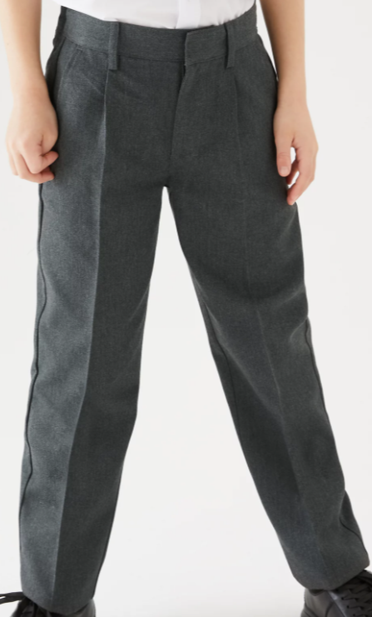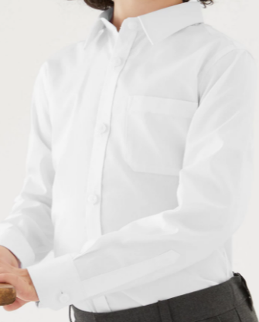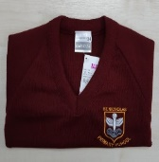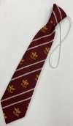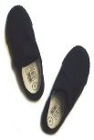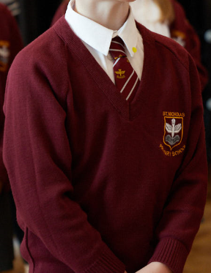  Summer  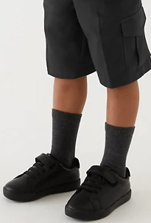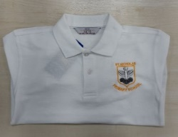
Girls  Maroon knitted jumper or cardigan with school badge  School tie  White shirt  Grey skirt/culottes or pinafore  Grey tailored trousers - Jeans and lycra trousers/leggings are not permitted  Red and white gingham check dresses can be worn in the Summer term | Winter  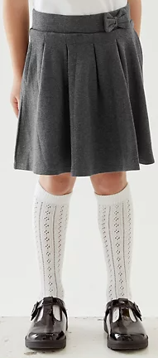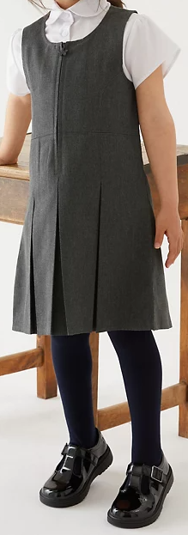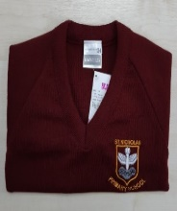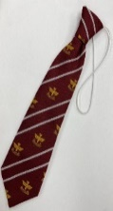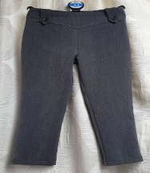  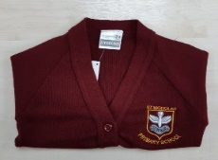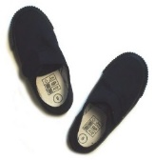  Summer  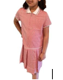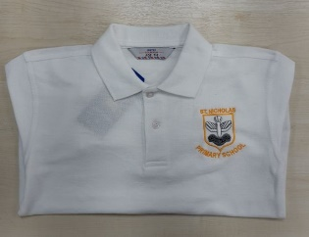
P.E kit for boys and girls consists of:  Plain black tee shirts (all classes)  Plain black shorts (all classes)  Maroon PE Bag kept in school with PE kit  ALL CHILDREN WEAR BLACK PUMPS IN SCHOOL | 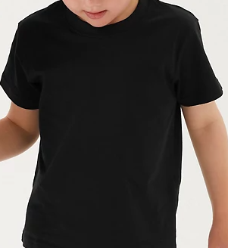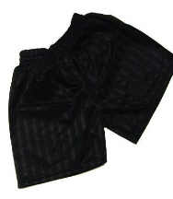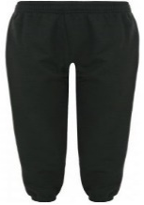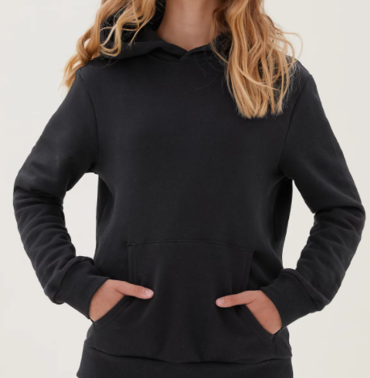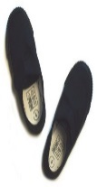
Optional PE bag | 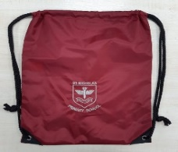
Book bag needed for Foundation and Key Stage One children | 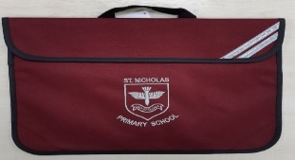

Jewellery
- At St Nicholas children should only wear one pair of small, plain stud earrings. These should not be worn on P.E. or swimming days.
- If children come to school wearing earrings on P.E. or swimming days they will have to take the earrings out themselves or cover them over with a plaster or Micro pore tape which they have brought from home.
- Children can wear a watch.
- Teachers do not take responsibility for looking after jewellery.

General Appearance
- Children should not wear nail varnish, make up or any tattoos, including the stick on variety.
- Long hair should be tied back. This is particularly important in order to prevent the spread of head lice.
- Hair accessories such as slides, hair bands, ribbons, bobbles should be fairly simple and manageable.
- Parents are asked to ensure children’s hair styles are appropriate for school. Extremes of hairstyle including bright colours, tramline designs and shaved heads are not permitted.
- Children should not bring mobile phones to school. If an older pupil needs one to use after school to get in touch with their family they can leave it at the school office during the school day.

Disability Equality Impact Assessment

This policy has been written with reference to and in consideration of the school’s Disability Equality Scheme. Assessment will include consideration of issues identified by the involvement of disabled children, staff and parents and any information the school holds on disabled children, staff and parents.

Any questions or concerns regarding this policy should be made to the school office.

