Year 4 Autumn 1 Homework Leaflet

Each half term, children will receive their homework leaflet, that outlines their weekly homework, plus their half-term project focus. The project can be completed over the course of the full half-term and brought into school when completed. Across the school year, the projects will focus on a variety of areas of the curriculum, linked to our class topics, allowing the children to express their thoughts and ideas, in their own creative manner. Weekly homework and spellings will be sent out on a Tuesday and is to be returned to school on a Monday.
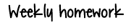

Each week, children should aim to complete:

- If your child is on a Read write Inc scheme, books will go out on Thursday this week.

- Practise of their weekly spellings, which can be found in their homework wallet and on their class page, via the school website. Spelling Shed is a new platform the children have access to for practising their spellings.

- Reading aloud of their take home reading book or Read Write Inc book.

- Maths practise to secure learning. This is set via Mathletics and will further develop skills taught in school.

- Children may work on their project focus in their own time. The focused project is due at the end of the half term.

Please log into times table rock stars and practice your times tables.

Please only complete the tasks you are assigned as this links with what they have been taught in school.
For the week commencing 1st September please log in to TT Rockstars and practice whilst Mathletics classes are established.

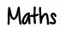
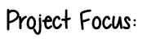

- 🎨 This half term, your project is all about the Arts!
You’ll get to explore Music, Languages, Art, and Design Technology in creative and exciting ways. Choose one of the ideas below (or get inspired to add your own twist!):
- ✨ Origami Art
Have a go at making a collection of origami models. See how careful folds can magically turn a simple piece of paper into animals, shapes, or objects!
- 🍴 Model a Spanish Dish
Research a traditional Spanish dish and bring it to life by creating a 3D model. You could use art materials or even recycled items to make it look delicious.
- 🎵 Sing it in Spanish
Learn, practise, or even write a short song in Spanish! It could be a favourite tune with new Spanish words or an original piece of your own.




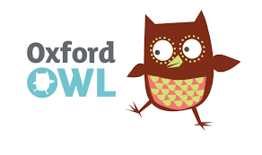



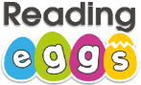
research

Ongoing spellings
Your child will be tested termly on the Year 3 and 4 statutory spelling list. A list of these words will be handed out to your child. The highlighted words are the words your child has spelt and can read correctly. The words which are not highlighted are the words your child needs additional practise with in order to spell accurately. Please ensure these spellings are practised regularly at home as part of your ongoing learning.



