Year 3 Autumn 1 Homework Leaflet

Each half term, children will receive their homework leaflet, that outlines their weekly homework, plus their half-term project focus. The project can be completed over the course of the full half-term and brought into school when completed. Across the school year, the projects will focus on a variety of areas of the curriculum, linked to our class topics, allowing the children to express their thoughts and ideas, in their own creative manner. Weekly homework and spellings will be sent out on a Tuesday and is to be returned to school on a Monday.

Each week, children should aim to complete:
- Practise of their weekly spellings, which can be found in their homework wallet and on their class page, via the school website. Spelling Shed is a platform the children have access to for practising their spellings.

- Reading aloud of their take home reading book or Read Write Inc book. If your child is on the RWI scheme books will be sent out on Thursday. All other books will be set on Tuesday.

- Children may work on their project focus in their own time. The focused project is due at the end of the half term.

Please log into times table rock stars and practice your times tables.

Please only complete the tasks you are assigned as this links with what they have been taught in school.

For the week commencing 1st September please log in to Times Tables Rock Stars and practice.

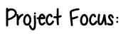
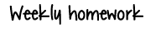
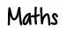

🎨 This half term, your project is all about the Arts!
You’ll have the chance to be imaginative and creative by choosing one of the exciting activities below:

🎶 Art Inspired by Music
Create a piece of artwork based on your favourite music or song. Think about how the music makes you feel and use colours, shapes, or patterns to show its mood.

🏛️ Research and Build a 3D Structure
Pick a structure to explore, then build your own 3D version!
It could be a Stone Age house, a famous building, a bridge, or even a sculpture.

🥁 Design and Create a New Musical Instrument
Invent your own instrument! It could be a shaker, a drum, a string instrument, or something completely new. Think carefully about how it will make sound and what materials you could use.



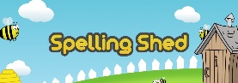




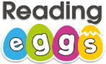
research

Ongoing spellings
Your child will be tested termly on the Year 3 and 4 statutory spelling list. A list of these words will be handed out to your child. The highlighted words are the words your child has spelt and can read correctly. The words which are not highlighted are the words your child needs additional practise with in order to spell accurately. Please ensure these spellings are practised regularly at home as part of your ongoing learning.

