Year 3/4 Topic Leaflet Miss Chatt

English
In English, the children will explore the book Stone Age Boy. Using this text, they will produce a range of outcomes, including a time-slip narrative, instructional writing, and a non-chronological report about life in the Stone Age.
Year 3 children will work on using the present perfect tense, speech marks to show dialogue, imperative verbs in instructions, prepositions to add detail, and writing in clear paragraphs. Year 4 children will extend their grammar by practising fronted adverbials, using cohesive pronouns to link ideas, and applying accurate past tense forms such as was and were.

Maths
Year 3 children will develop their understanding of place value with numbers up to 3-digits through partitioning, number lines, and counting. They will compare and order numbers to 1,000 and practise addition and subtraction using both mental strategies and written methods, building fluency, reasoning, and problem-solving confidence. Year 4 children will extend their understanding of place value to 4-digit numbers using partitioning, number lines, and counting. They will compare and order numbers up to 10,000 and practise addition and subtraction using mental and written strategies. The children will also use estimation and solve multi-step problems, developing fluency, reasoning, and problem-solving confidence.

RE
Our first topic this term is ‘The Christian Family’. Within this topic the children will develop their knowledge and understanding of the Sacrament of Baptism. The children will explore and reflect on what it means to be a part of a family, understand that the Church is the family of God and reflect on what it means to be part of the Christian family.
Our next topic is ‘Mary, Mother of God’. Within this topic the children reflect on the role of Mary, develop their understanding of Advent as a time of preparation for the birth of Jesus and are encouraged to reflect on the true meaning of Christmas.

Science
This term in Science, the children will be learning focusing on Physics by learning about energy through the topic Electricity and Circuits. The children will discover that electricity needs a complete circuit to work and that switches can be used to turn things on and off. They will explore how batteries power circuits and investigate which materials let electricity flow (conductors, like metal) and which do not (insulators, like plastic). The children will also learn how to stay safe around mains electricity. By the end of the topic, the children will be able to build a simple circuit, test materials, and explain how electricity works in everyday life.

History
This term the children will be stepping back in time to explore the Stone Age and Iron Age. They will learn how life changed across these periods, from the earliest stone tools to the use of bronze and iron. The children will discover what daily life was like in the Iron Age – including the food people ate, the homes they built, and the tools they used. They will also find out how archaeologists uncover the past and why artefacts, such as tools and pottery, are so important. The children will explore Iron Age settlements, including hillforts and roundhouses, and learn how Britain’s landscape changed over time.

Core text:
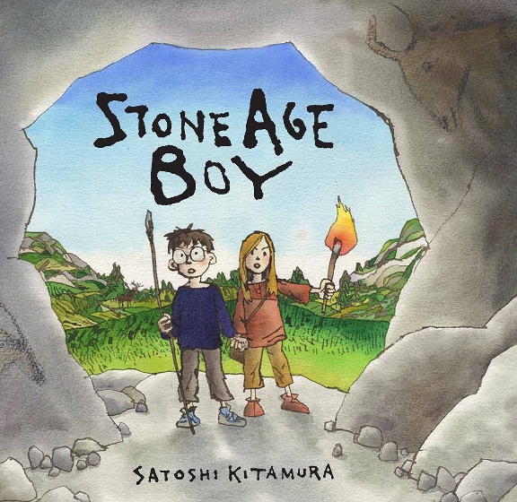

PE
In PE, children develop football skills: stopping, passing, dribbling, tackling, and shooting. They practise control, accuracy, and teamwork, applying simple tactics for attacking and defending while playing small-sided games with confidence.
The year 4 children will be going swimming this year, this focuses on water confidence, safe entry, floating, basic strokes, breathing, endurance, and essential water safety skills.

MFL
This term children will begin by learning basic greetings and using simple conversational phrases. We will also focus on counting from 1 to 20, and the children will begin to recognise and name the days of the week and the months of the year in Spanish.

A few reminders:
- Year 3/4 will start their school day at 8.40am and finish at 3.30pm.
- PE is on Monday, Wednesday and Friday. Please make sure children bring in their full and correct PE kit.
- Year 4 children will go swimming every Wednesday, your child must bring a swimming costume/ shorts and a towel, googles can also be worn.
- Children MUST bring pumps into school to wear indoors. Please clearly label the pumps with your child’s name.
- Please ensure that all uniform, coats, pumps and PE kits are clearly labelled with your child’s name.
- It is very important that the children be listened to read regularly. Once the children have read their book, they must bring it back to school so that it can be changed.
- Ensure all children bring in a water bottle. It is really important that the children stay hydrated throughout the day.

PSHE
In the first topic, the children learn what drugs are, explore the risks of smoking and second-hand smoke, and discuss support for quitting. They consider health benefits, laws, and strategies for staying smoke free. In the second topic, the children learn to recognise, respond to, and report bullying, including online. They explore different types of bullying, understand its impact, and discuss strategies for seeking help and supporting others.

Computing
In Computing, the children will explore how networks work. They will learn that devices connect through wired or wireless systems, with servers storing and sharing files. The children will investigate how websites travel to their computers, discover the roles of routers and data packets. This will build their understanding of digital systems and communication.

Art
In Art, the children explore gestural drawing with charcoal, using movement and bold marks to capture drama. This approach develops creativity, imagination, and confidence, encouraging expressive storytelling beyond traditional observational drawing.
In DT, the children design and create clay pots, exploring form, function, and decoration. They will develop practical skills, refine techniques, and evaluate their work

Music
This year children will work with Cathedral Choir to explore singing, rhythm, and performance. They will develop listening skills, learn to follow notation, and perform as part of an ensemble. This experience supports the Lower Key Stage 2 curriculum, building confidence, teamwork, and enjoyment through high-quality musical opportunities.

Test me on my vocabulary!
vibration circuit condensation preposition
battery baptism evaporation sacrament
sound wave incarnation archaeologist annunciation

“Love one another as I have loved you”

