Year 5 Topic Leaflet Miss Hayden
Visit your class blog under the Children’s section of the school website to find the knowledge organisers for this term’s topics.
English
In our English this term, we will be focusing on ‘Goodnight Mr Tom’ as our writing stimulus. Throughout the term, we will explore a range of writing outcomes starting with a narrative, then moving onto a formal letter, and finishing with a newspaper report. They will write for a range of purposes and audience and build up their drafting, writing and editing skills, whilst learning new grammar features such as expanded noun phrases, fronted adverbials, relative clauses and parenthesis which they will apply into their writing.

Maths
Over the next term Year 5 will be focusing on:
- Place value- Roman numerals, representing, comparing numbers and rounding, partitioning and reading and writing numbers to 1000000.
- Addition and subtraction – using mental strategies develop their fluency, inverse operations, rounding to check answers and multi-step problem.
- Multiplication and division – multiples, factors, prime, cube and square numbers, multiply and divide by 10, 100 and 1000.

RE
Our topics this term are ‘Creation’ and ‘God’s Covenants’. In our creation topic we will focus on the story of Creation and the story of The Fall from the book of Genesis. The children will be expressing their own points of view regarding the stories and they will work on making links between the actions of Adam and Eve and suffering in the world. In the God’s Covenants topic, the children will develop an understanding of God’s covenant with Noah and Abraham. The children will focus on The Exodus and the challenges faced by the Israelites. Through these teachings, the children will discover how God remained faithful even in times of difficulty.
king up Bible reference

Science
This term, your child will be exploring the unit “Animals Including Humans”. The focus is on understanding how the human body works and how it changes over time. The first topic of ‘Human Timelines,’ will enable children to describe and explore changes as humans develop from infancy to old age and be able to identify and understand key stages of human development and growth. We will then use this understanding to compare with other groups of animals to identify similarities and differences. Then we will move onto the topic of Circulation and Health where we will learn about the structure and function of the heart, blood, and blood vessels, explore how nutrients and water are transported around the body and learn how lifestyle choices affect health.

History & Geography
We will start the term with History learning about World War II. We will explore what caused WWII, evacuation and rationing, and the impact the war had on the rest of the world as well as the future of the countries involved. The children will identify key events that make up the timeline of WWII as well as exploring maps and recounts. Later in the term, we will look at Geography, learning about Our Changing World. We will explore the difference between weather and climate, the impact of erosion of settlements and landscapes, and discuss the concept of urbanisation. We will recognise the importance of biodiversity and sustainability and propose ways of reducing climate change globally.

Our whole class novel
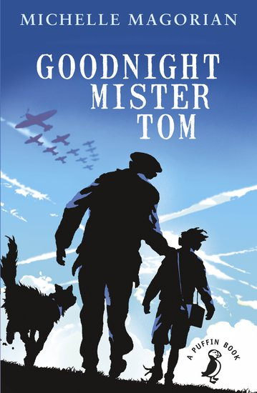

PE
This term, the children will be doing dance, with a focus on WW2. They will also have the opportunity to develop their skills in invasion games, particularly hockey and basketball. The children will learn defence and attack skills, as well as passes and how to run a competitive game.

MFL
In Spanish this term, our theme is ‘Me and My Town’. We will start by introducing ourselves with simple sentences and explain how we feel. We will then move onto exploring school subjects and giving opinions, as well as giving simple directions around a town and roleplaying buying items. They will have the opportunity to develop their written, oral and written skills within all lessons.

A few reminders:
- Year 5 will start their school day at 8.40am and finish at 3.30pm.
- PE is on Monday, Wednesday Thursday, and Friday. Please make sure children bring in their full and correct PE kit.
- Children MUST bring pumps into school to wear indoors. Please clearly label the pumps with your child’s name.
- Please ensure that all uniform, coats, pumps and PE kits are clearly labelled with your child’s name.
- It is very important that the children be listened to read regularly. Once the children have read their book, they must bring it back to school so that it can be changed.
- Ensure all children bring in a water bottle. It is really important that the children stay hydrated throughout the day.

Art & DT
This term in Art, we will be creating Blitz silhouettes using a range of media. They will focus on the striking contrast between the fiery skies and the blacked-out city skylines using chalk and blending techniques. We will then move onto propaganda posters, exploring the bold images and short captions. We will create our own stencils and use these to print onto paper. In DT, we will look at materials and structures, designing and create Anderson shelters.

Test me on my ninja vocabulary!
rounding steward thousandths life cycle
programming prejudice me gusta/ no me gusta
propaganda development co-creator migration

Computing
Our computing topic this term is ‘Programming: Music’. The children will explain what basic commands do, design a program linking to a theme and insert a simple loop and code a piece of music that combines a variety of structures. They will also recognise that programming music is a way to apply their skills.

Music
This term, we are exploring the song: What shall we do with the drunken sailor? And other sea shanties. The children will research the history and context of a sea shanty. They will be inspired to create their own rhythm games and will perform class arrangement using their voices and a range of different instruments.

PSHE
This term we will be looking at Physical Health and Wellbeing focusing on the media. We will explore how adverts can be misleading, how the media can portray role models and how images online may not always reflect reality. We will look at Identity, Society and Equality, exploring the ideas area prejudice and discrimination and how this makes us feel.

“Love one another as I have loved you”

