Year 6 Autumn 1 Homework Leaflet

Each half term, children will receive their homework leaflet, that outlines their weekly homework, plus their half-term project focus. The project can be completed over the course of the full half-term and brought into school when completed. Across the school year, the projects will focus on a variety of areas of the curriculum, linked to our class topics, allowing the children to express their thoughts and ideas, in their own creative manner. Weekly homework and spellings will be sent out on a Tuesday and is to be returned to school on a Monday.
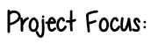

Each week, children should aim to complete:
- Practise of their weekly spellings, which can be found in their homework wallet and on their class page, via the school website.

- Reading aloud of their take home reading book or Read Write Inc book.

- Maths practise to secure learning. This is set via Mathletics and will further develop skills taught in school.

- Children may work on their project focus in their own time. The focused project is due at the end of the half term.

STEM Project Focus:
This half term, we would like you to create a stem project based on Evolution and Inheritance. At the end of Year 5, the children learnt about this topic. Children may select from the list below:

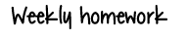
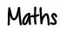

Family Tree Fun:
- Draw a simple family tree for 2–3 generations (parents, grandparents, siblings).
- Add traits like hair colour, eye colour, or freckles.
- Highlight which traits were inherited from parents or grandparents.
Design a Creature:
- Invent a new species and design its traits (fur colour, limb length, diet).
- Explain how these traits help the creature survive in a specific habitat.
- Draw or 3D model the creature.
- Use simple measurements or ratios for limbs, body size, etc., integrating math skills.
Nature Walk Observation
- Go for a short walk in the garden, park, or nearby area.
- Observe animals and plants. Note any special features (long legs, spotted fur, thick leaves).
- Create a presentation to describe how these traits might help them survive in their environment.


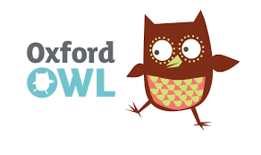




research

Ongoing spellings

Your child will be tested termly on the Year 5/6 statutory spellings. A list of these words will be handed out at parents evening. The highlighted words are the words your child has spelt correctly. The words which are not highlighted are the words your child needs additional practise with in order to spell accurately. Please ensure these spellings are practised regularly at home as part of your ongoing learning.

