Year 5 Autumn 1 Homework Leaflet

Each half term, children will receive their homework leaflet, that outlines their weekly homework, plus their half-term project focus. The project can be completed over the course of the full half-term and brought into school when completed. Across the school year, the projects will focus on a variety of areas of the curriculum, linked to our class topics, allowing the children to express their thoughts and ideas, in their own creative manner. Weekly homework and spellings will be sent out on a Tuesday and is to be returned to school on a Monday.
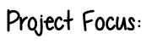

Each week, children should aim to complete:
- Practise of their weekly spellings, which can be found in their homework wallet and on their class page, via the school website.

- Reading aloud of their take home reading book or Read Write Inc book.

- Maths practise to secure learning. This is set via Mathletics and will further develop skills taught in school.

- Children may work on their project focus in their own time. The focused project is due at the end of the half term.

STEM Project Focus:
This half term, we would like you to create a stem project based on Ancient Maya. At the end of Year 4, the children learnt about this topic so should have some knowledge and understanding. Children may select from the list below:

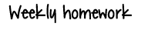
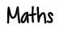

Mayan Number System
- Research the basics: dots = 1, bars = 5, shell = 0.
- Have a go at writing your age, the number of pets you have, or a favourite number using Mayan numerals.
- Bonus: Try adding two numbers using Mayan numerals.
Build a Mayan Pyramid
- Use blocks, cardboard, or paper to make a small pyramid.
- Try to calculate: total number of “steps” or levels and the perimeter and base area of each level.
Astronomy and the Mayan Calendar
- Ask students to pick a night and record:
- Moon phase
- Visible planets or constellations
- Make a small calendar of moon phases for the month and see if it matches an online lunar calendar.
- Compare your observations to ancient Mayan records—can you see patterns?


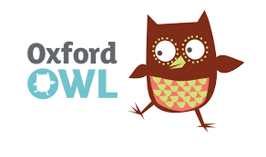



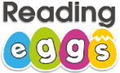
research

Ongoing spellings

Your child will be tested termly on the Year 5/6 statutory spellings. A list of these words will be handed out at parents evening. The highlighted words are the words your child has spelt correctly. The words which are not highlighted are the words your child needs additional practise with in order to spell accurately. Please ensure these spellings are practised regularly at home as part of your ongoing learning.

